Calculation Program:

#include<stdio.h>

#include<conio.h>

main()

{

int choice, a, b, i, sum;

printf("Welcome to my calculator\n");

start:

printf("\n1. Add numbers");

printf("\n2. Subtract numbers");

printf("\n3. Multiply numbers");

printf("\n4. Divide numbers");

printf("\n5. Exit");

printf("\nEnter your choice:: ");

scanf("%d", &choice);

switch(choice)

{

case 1:

{

add:

printf(" \*\*\*\*\*\* Addition \*\*\*\*\*\* ");

printf("\nEnter First number : ");

scanf("%d",&a);

printf("\nEnter Second number : ");

scanf("%d",&b);

sum=a+b;

printf("\nAddition is :: %d", sum);

printf("\nDo you want to continue Addition 1 : ");

scanf("%d", &i);

if(i==1)

{

system("cls");

goto add;

}

else

goto start;

break;

}

case 2:

{

sub:

printf(" \*\*\*\*\*\* Substract \*\*\*\*\*\* ");

printf("\nEnter First number : ");

scanf("%d",&a);

printf("\nEnter Second number : ");

scanf("%d",&b);

sum=a-b;

printf("\nSubtract is :: %d", sum);

printf("\nDo you want to continue Subtract 1 : ");

scanf("%d", &i);

if(i==1)

{

system("cls");

goto sub;

}

else

goto start;

break;

}

case 3:

{

multi:

printf(" \*\*\*\*\*\* Multiply \*\*\*\*\*\* ");

printf("\nEnter First number : ");

scanf("%d",&a);

printf("\nEnter Second number : ");

scanf("%d",&b);

sum=a\*b;

printf("\nMultiply is :: %d", sum);

printf("\nDo you want to continue Multiplication 1 : ");

scanf("%d", &i);

if(i==1)

{

system("cls");

goto multi;

}

else

goto start;

break;

}

case 4:

{

div:

printf(" \*\*\*\*\*\* Divide \*\*\*\*\*\* ");

printf("\nEnter First number : ");

scanf("%d",&a);

printf("\nEnter Second number : ");

scanf("%d",&b);

sum=a/b;

printf("Divide is :: %d", sum);

printf("\nDo you want to continue Division 1 : ");

scanf("%d", &i);

if(i==1)

{

system("cls");

goto div;

}

else

goto start;

break;

}

default:

printf("Bye");

}

}

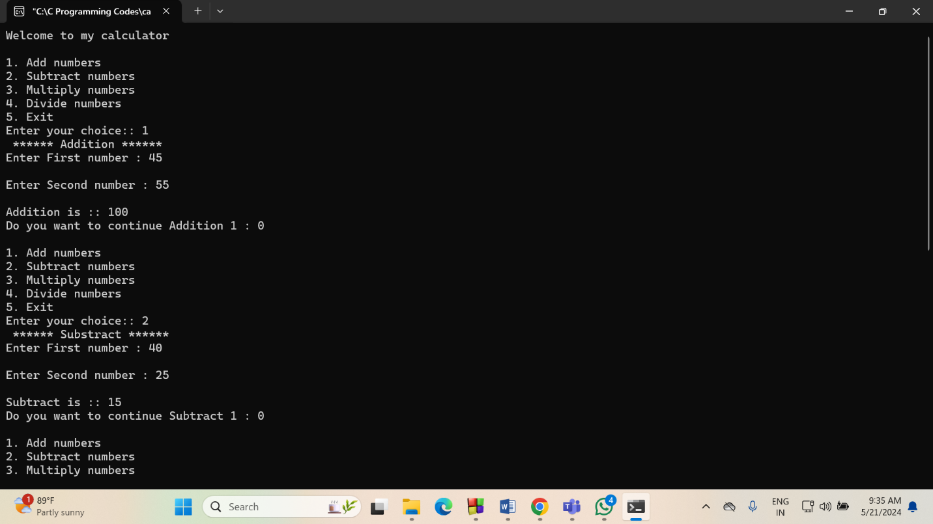Output:

